Iowa’s Pork All Americans

2022
Winters, Curt - Sioux Center

2021
Schnepf, Matt & Angie - Le Mars

2020
Dolan, Mark - Masonville

2019
Nieland, Aaron & Alyce - Breda

2018
Brands, Gerry and Gary – Inwood

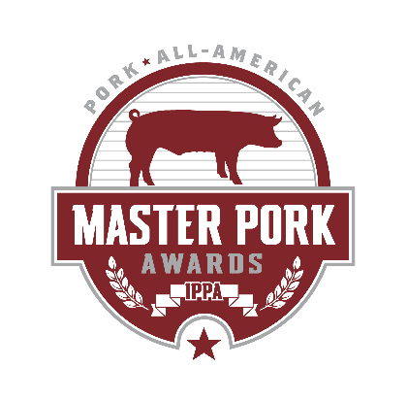
2017
Johnson, Ben & Janelle - Ireton

2016
Brenneman, Tim & Erin - Washington

2015
Van Gelder, Brad & Terri - Creston

2014
Reed, Ryan - Ottumwa

2013
Pingel, Paul - Aurelia

2012
Dolan, Sean - Masonville

2011
Berdo, Dan & Rachel - Washington

2010
Cook, Aaron & Trish - Winthrop

2009
Ver Steeg, Mike & Sarah - Inwood

2008
Sleezer, Dana & Nicky - Aurelia

2007
Wiley, Todd - Walker

2006
Monaghan, Brian - Masonville

2005
Van Gilst, Joel & Bryce - Oskaloosa

2004
Pech, Mike – Winthrop

2003
Knoblock, Thadd, Travis, Trent & Troy - Rock Rapids

2002
Moody, David - Ames

2001
Burt, Allen & Darrel - Marshalltown

2000
McDonald, Tom & Nancy - Hopkinton

1999
Floy, Tom - Thornton

1998
Conley, Marla - Cherokee

1997
Moser, Rick & Brad - Larchwood

1996
Mogler, Rodney, Brian, Dwight & Perry - Alvord

1995
Brenneman, Rob & Char - Washington

1994
Scallon, Joe & Linda - Iowa Falls

1993
Coon, Roger & Linda - Lohrville

1992
Caspers, Jon - Swaledale

1991
Vittetoe, Jerome and Heidi - Washington

1990
Korslund, Dr. John A. - Eagle Grove

1989
Vos, Arvin & Laura - Otley

1988
Litscher, David - Stanwood

1987
Bovy, Michael - Waterloo

1986
Paustian, Kent & Ross - Walcott

1985
Dircks, Robert Jon - Clarence

1984
Friest, Dennis - Radcliffe

1983
Baker, Dennis & Robert - State Center

1982
Trask, Harold - Renwick

1981
Miller, Duane - Wellman

1980
Hausman, Dave - Onawa

1979
Riggan, Bill - Washington

1978
Sobolick, Jim - Cresco

1977
Kuhn, Keith - Moville

1976
Smith, Cliff - Jefferson

1975
Bjustrom, Charles - Whittemore

1974
Van Gilst, Ken - Oskaloosa

1973
Keppy, Allen - Wilton

1972
Cook, Lisle - Hubbard

1971
McCreedy, Wilfred - Ainsworth

1970
Thomas, Ernie - Waukee

1969
Lefebure, Don - Fairfax

